Mark Geha Lecture 2

704769079 Discussion 2A

Problem Set 0

See Code on Github: [www.github.com/markgeha8](http://www.github.com/markgeha8)

4a)

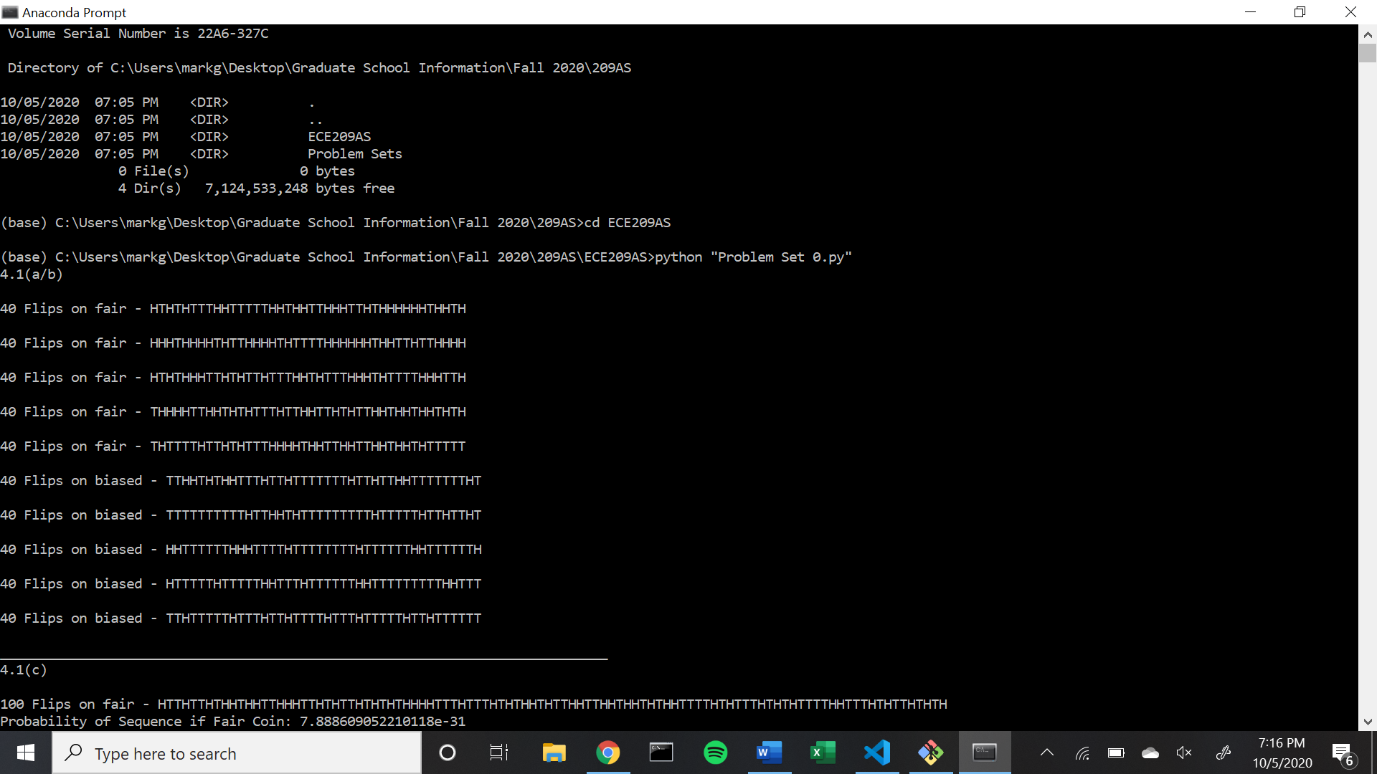

4c/d)

